C A T S
CUMBRIA ADVISORY THYROID SERVICE
SPRING 2016 - News Update

Long may C.A.T.S. continue to give hope to Thyroid patients everywhere


HOPE

Hello Everyone

Welcome to our Spring news update, thank you to everyone who sent Christmas cards, Christmas wishes, and extra donations along with their membership renewals. A warm welcome goes out to the friends who have joined us recently especially everyone from the former TFNC group. We had lots of feedback from our bumper edition and I am happy to say most of our members liked the idea of having a bumper edition twice a year, plus two mini editions. So here we go with the first of our mini news up-dates.

Thyroid Friends.
We are still taking new members, so if you want to become a friend and support the work we do please contact me at the office. (Membership is just £6.00 per year.) We do prefer payment by cheque but if you wish to pay by other methods please contact me. Thank you to everyone that already supports us in so many ways.

Gold Stars *
Look out for a gold star on your newsletter, this indicates your membership is due for renewal soon, If you get your newsletter by e-mail you will receive a separate e-mail.

Website
Just to remind you our new website is almost ready to be viewed, you will find lots of useful information for Thyroid patients so why not take a look at www.cumbriancats.co.uk also don’t forget to like our Facebook page at www.facebook.com/pagesCumbria-Advisory-Thyroid-Service-C.A.T.S./13874768249218

Help us to save money

One of the biggest costs for running the group is postage. So if you want to help us save money why not have your newsletter delivered by e-mail. For more details contact Peter at richjon@talktalk.net (You can opt back to paper copies any time you wish.)

C.A.T.S. Meetings up-date

We are currently finalising our meeting schedule for 2016 however we are pleased to announce meetings in Barrow, Kendal & Penrith. Look out for more information and how to book in the next bumper edition. In the meantime, we do have some news about a Barrow Thyroid Support Group that has been set up recently. They meet informally every fortnight at the Duke of Edinburgh Hotel and offer a relaxed environment to exchange ideas and experiences with fellow thyroid sufferers. For details ring Julie on 07547674903.

Competition winner

Congratulations to Della who correctly answered our question, and was the first name pulled out of the hat. Hope you enjoy spending your voucher Della.



Managing your Thyroid problems

Thyroid conditions can be very complex and the advice that suits one patient may not suit another therefore CATS always recommends that you should seek advice from your GP before altering your medication.

* Get a diagnosis as soon as possible (this is sometimes the hardest thing to do)
* Understand about Thyroid disease, become more Thyroid aware, report any new symptoms to your GP.
* Know the difference between Hypo (underactive) and Hyper(overactive) and the symptoms with each condition.
* Understand about other conditions that link in with Thyroid disease (did you know there are over 300 different conditions that you may develop if your Thyroid is malfunctioning.)
* Don’t forget to have regular blood tests and always make a note of the results so you can see how your Thyroid is working.
* Eat a healthy diet and drink plenty of water (this helps to flush out the toxins and also reduces fluid retention.)
* Explore extra therapies such as reflexology and massage to help rebalance your body.
* Always communicate with your GP and other health advisor

Thyroid Awareness Week

Did you know there is an official international Thyroid Awareness Week. This year the event takes place during the week of May 23rd -29th to celebrate this event I have arranged a table within forum 28 on Wednesday 25th May between 11am and 2pm. If you would like to help us raise the awareness of this important health condition please get in touch with me at the C.A.T.S. office.
To All Our Members

That’s all for now folks
We will be back again in June with our next bumper edition. until then keep well, keep happy.
If you want to contact the office ring 01229 869705.
Or you can e-mail moyra@cumbriancats.co.uk or moyramm@yahoo.co.uk or write to us at
The Old Cottage, Garden Terrace, Baycliff, Ulverston, LA12 9RP.
Best Wishes
Moyra

CATS – Information Guidelines
FREEDOM OF INFORMATION RULES

Please note that all information supplied to CATS will be treated with the
strictest of confidence and will not be passed on to any other source.
ALL CATS VOLUNTEERS WORK TO STRICT CONFIDENTIALITY
RULES AT ALL TIMES

Any information produced in this newsletter is to help those suffering with thyroid disease. Whilst every effort is made to provide accurate information, it is impossible to ensure that the information given is relevant to every individual. No responsibility is accepted by C.A.T.S.and it is recommended and essential that if in any doubt about your condition that you should always contact your doctor, specialist physician or surgeon to seek medical advice.

C.A.T.S recommends that you ALWAYS seek your Doctor’s advice
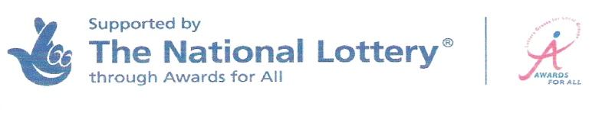

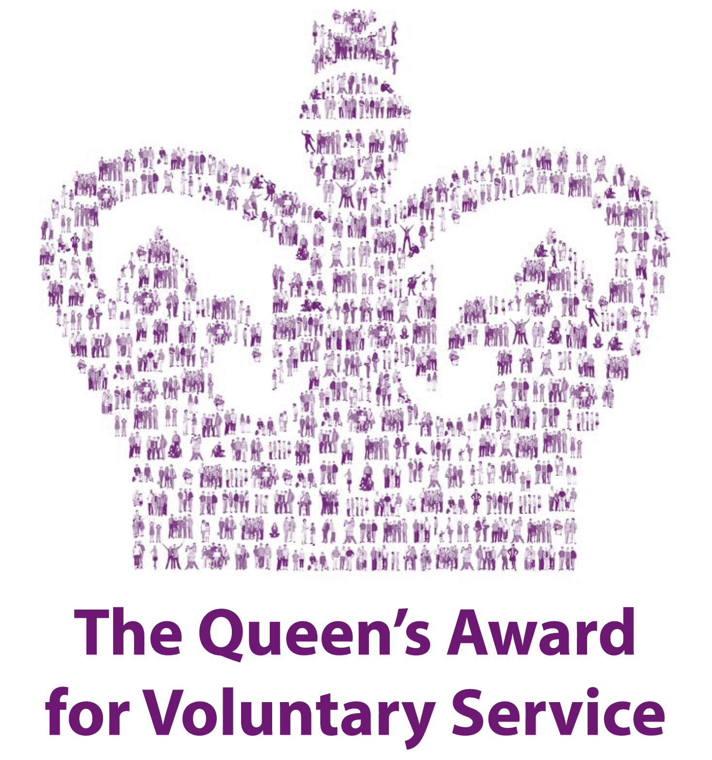
SUPPORTED BY

